Unveiling Market Insights: Analysing Spending Behaviour And Identifying Opportunities For Growth

**1.INTRODUCTION**

* 1. **OVERVIEW:**

Wholesaling or distributing is the sale of goods to retailer to [industrial](https://en.wikipedia.org/wiki/Manufacturing), commercial, institutional or other professional businessman to other wholesalers (wholesale businesses) and related subordinated services. Wholesaling is buying goods in bulk quantity, usually directly from the manufacturer or source, at a discounted rate. The retailer then sells the goods to the end consumer at a higher price making a profit.

The consumption and production of marketed food are spatially separated. Production is primarily in rural areas while consumption is mainly in urban areas.In today's highly competitive business landscape, gaining deep market insights is essential for businesses to thrive and grow. This project aims to analyze customer spending behavior and identify opportunities for growth by leveraging data analytics and data-driven decision-making.

* 1. **PURPOSE:**

The project described aims to utilize data analytics and data-driven decision-making to analyze customer spending behavior. By doing so, businesses can gain a deeper understanding of their customers, their preferences, and their purchasing patterns. With this valuable insight, companies can make more informed and strategic decisions to drive growth and success. Specifically, through this project, businesses can achieve several objectives:

**Customer Segmentation:** By analyzing spending behavior, the project can help identify different customer segments with unique preferences. This allows businesses to tailor their marketing and product offerings to specific customer groups.

**Optimized Product Offerings:** Understanding what products or services are most popular among customers can help businesses optimize their offerings, ensuring that they meet market demands effectively.

**Inventory Management:** Data analytics can aid in more accurate demand forecasting, leading to better inventory management and reduced waste.

**Pricing Strategies:** By analyzing spending behavior, businesses can refine their pricing strategies to maximize profits while remaining competitive.

**Marketing Campaign Effectiveness:** The project can assess the performance of marketing campaigns and identify which strategies resonate most with customers, enabling businesses to allocate resources more efficiently.

**Customer Retention:** Insights from this project can help improve customer satisfaction and loyalty by tailoring services to individual preferences.

In summary, this project empowers businesses to make data-driven decisions that enhance their competitiveness, customer satisfaction, and overall growth in a highly competitive business environment.

**2. PROBLEM DEFINITION & DESIGN THINKING:**

**2.1 EMPATHY MAP:**

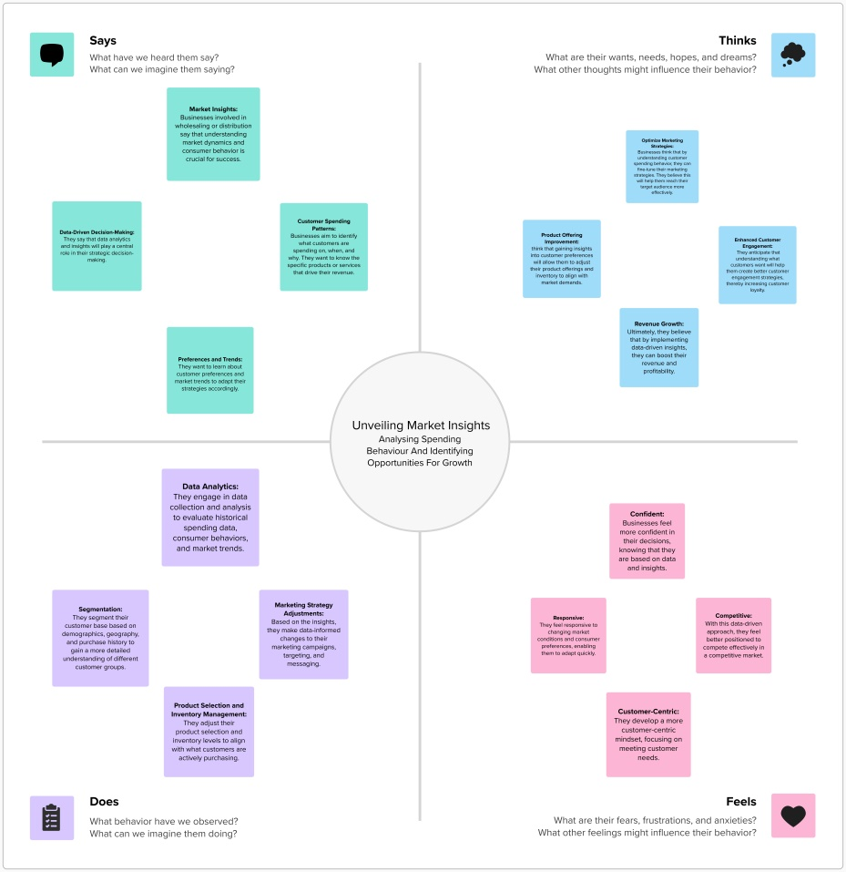

**2.2 IDEATION & BRAINSTROMING MAP:**

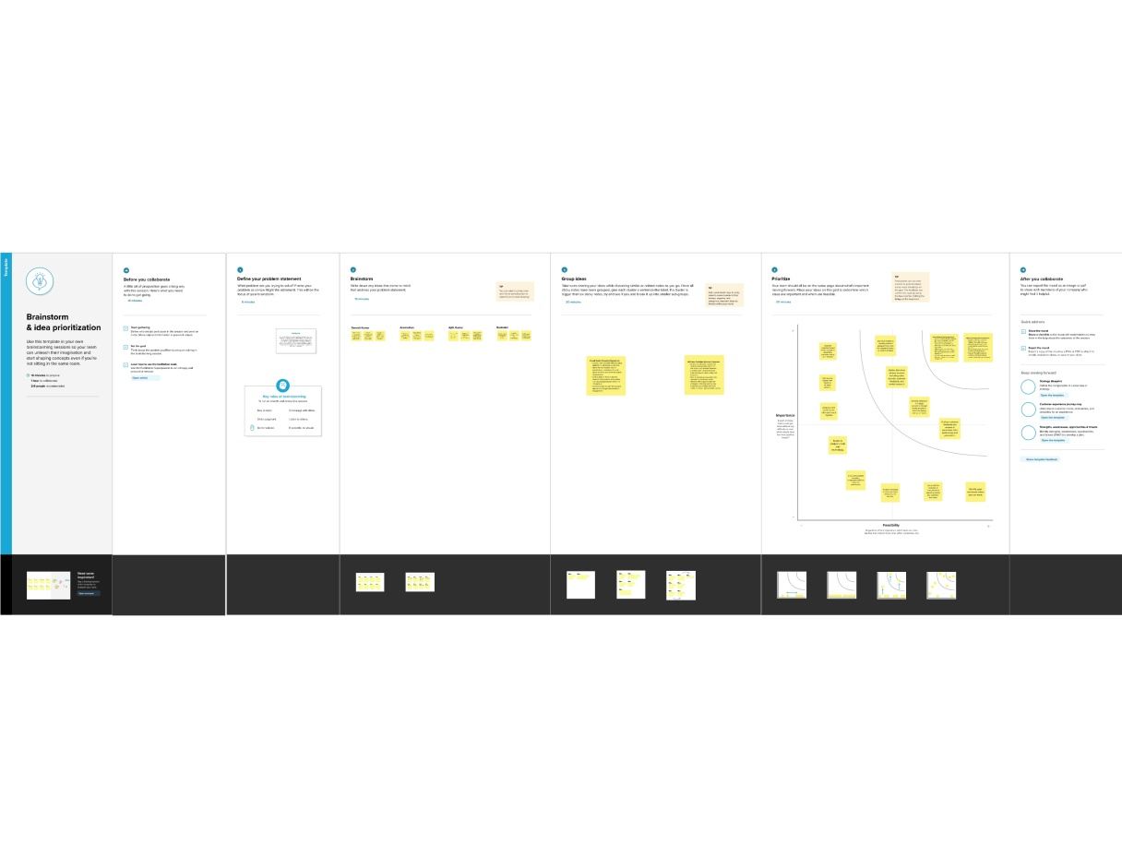

**3.RESULT:**

The provided text contains information about wholesaling or distributing, as well as the importance of gaining market insights through data analytics. The final findings of the project you mentioned are not included in the text. If you have specific questions or need information related to wholesaling, distributing, customer spending behavior analysis, or data-driven decision-making, please feel free to ask, and I'll be happy to provide more details or answer your questions.

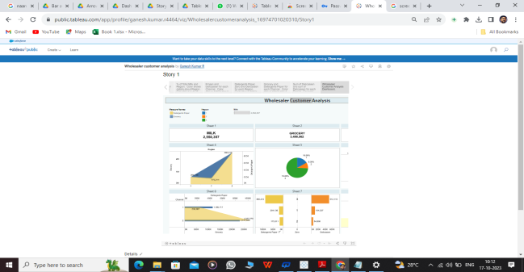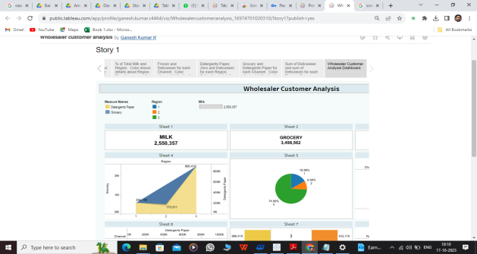

### 4. Advantages of the Proposed Solution:

1**. Data-Driven Decision Making**: Using data analytics allows businesses to make decisions based on real, actionable insights rather than relying on gut feelings or intuition. This can lead to more informed and effective strategies.

2. **Customer Behavior Insights**: Analyzing customer spending behavior can help businesses understand what products or services are in demand, when, and by whom. This information can guide inventory management and marketing efforts.

3. **Personalized Marketing**: Data analytics can enable businesses to tailor their marketing campaigns to individual customer preferences, leading to higher conversion rates and customer satisfaction.

4. **Cost Optimization**: By understanding customer behavior, businesses can optimize their operations, reduce waste, and cut unnecessary costs, ultimately improving profitability.

5. **Competitive Advantage**: Businesses that leverage data analytics are often better positioned to identify emerging trends and respond to market changes quickly, giving them a competitive edge.

6. **Scalability**: Data-driven insights can help businesses identify growth opportunities, allowing for more strategic and sustainable expansion.

### Disadvantages of the Proposed Solution:

**1. Data Privacy Concerns:** Collecting and analyzing customer data may raise privacy concerns, and businesses must adhere to strict regulations to protect customer information.

**2. Data Security Risks:** Storing and processing sensitive customer data makes a business a potential target for data breaches. Ensuring robust security measures is crucial.

**3. Cost of Implementation:** Implementing data analytics solutions can be expensive, particularly for small businesses. Costs may include software, hardware, and skilled personnel.

**4. Data Quality Issues:** Inaccurate or incomplete data can lead to incorrect conclusions and decisions. Ensuring data quality and integrity is a constant challenge.

**5. Overreliance on Data:** Relying solely on data-driven decisions may lead to neglecting qualitative factors and human intuition, which can also be important in decision-making.

**6. Complexity:** Data analytics can be complex, and interpreting results correctly may require a certain level of expertise. Businesses may need to invest in training or hire skilled professionals.

**7. Ethical Concerns:** There can be ethical dilemmas related to how customer data is used, particularly in terms of targeting and privacy. Companies must navigate these issues carefully.

In conclusion, while data analytics can provide numerous benefits for businesses, there are also challenges and ethical considerations that need to be addressed to ensure the responsible and effective use of customer data.

### 5. APPLICATION :

The provided text discusses wholesaling and its role in the distribution of goods, as well as the spatial separation between the production and consumption of food. It also touches on the importance of data analytics and data-driven decision-making in a competitive business environment. Let's explore the areas where this solution can be applied:

**1. Retail Industry :** Data analytics can be applied in the retail sector to analyze customer spending behavior. Retailers can use this information to optimize inventory management, improve product recommendations, and enhance the overall customer shopping experience.

**2. Supply Chain Management:** Data-driven decision-making is critical for optimizing the supply chain. Businesses can use data analytics to track the movement of goods from manufacturers to wholesalers to retailers, ensuring efficient logistics and inventory management.

**3. Wholesale and Distribution:** Wholesalers can leverage data analytics to identify trends and demand patterns. This information can help them make informed decisions about which products to stock and when to restock them.

**4. Manufacturing:** Manufacturers can use data analytics to gain insights into the demand for their products. This can assist in production planning and resource allocation.

**5. Agriculture and Food Production:** The spatial separation between food production in rural areas and consumption in urban areas highlights the need for efficient transportation and distribution networks. Data analytics can be applied to optimize these networks, reducing food waste and ensuring a stable food supply.

**6. Marketing and Advertising:** Understanding customer spending behavior is crucial in marketing and advertising. Marketers can use data analytics to tailor their campaigns to specific customer segments, improving the return on investment (ROI).

**7. E-commerce:** Online retailers can benefit from data analytics to personalize the shopping experience, recommend products, and optimize pricing strategies.

**8. Hospitality and Restaurants:** Restaurants and hotels can use data analytics to analyze customer preferences and spending patterns, helping them improve menu offerings, pricing, and overall service.

**9. Financial Services:** Banks and financial institutions use data analytics to understand customer spending habits and offer personalized financial products and services.

**10. Healthcare:** Hospitals and healthcare providers can apply data analytics to understand patient spending on healthcare services, enabling them to offer better care and financial guidance.

### 6. CONCLUSION :

In conclusion, wholesaling or distributing plays a crucial role in the supply chain, serving as the bridge between manufacturers and retailers. It involves the sale of goods in bulk at discounted rates to various types of businesses, such as retailers, industrial, commercial, and institutional enterprises. The retailer then sells these goods to end consumers at a higher price, generating a profit.

The distribution of goods is characterized by a spatial separation between production and consumption. Production primarily occurs in rural areas, while consumption is concentrated in urban areas. This geographical distinction underscores the need for efficient distribution networks to connect these two disparate regions.

In the contemporary business environment, marked by fierce competition, understanding customer spending behavior is paramount for a company's success and growth. Utilizing data analytics and data-driven decision-making is a valuable strategy to gain deep market insights. By analyzing customer data, businesses can identify trends, preferences, and opportunities for growth. This project underscores the significance of adopting data-driven approaches to remain competitive and make informed decisions in today's dynamic marketplace.

### 7. FUTURE SCOPE :

**1. Advanced Data Analytics Tools**: Invest in more advanced data analytics tools and technologies. This may include machine learning algorithms, predictive analytics, and artificial intelligence to gain deeper insights into customer behavior.

**2. Personalization:** Use the data to personalize marketing and product recommendations for individual customers. This can significantly improve customer satisfaction and increase sales.

**3.** **Supply Chain Optimization:** Extend data analytics to the supply chain. Predictive analytics can help optimize inventory management, reducing costs and ensuring products are available when needed.

**4.** **Market Segmentation:** Segment customers into different groups based on their spending behavior. This can help tailor marketing strategies for each segment more effectively.

**5. Real-time Data:** Implement real-time data analytics to respond quickly to changing customer preferences and market trends.

**6. Customer Feedback Analysis:** Utilize sentiment analysis and natural language processing to analyze customer feedback, reviews, and social media comments. This can help identify areas for improvement.

**7. Competitive Analysis:** Expand your analysis to include data on competitors. Understanding the competitive landscape can provide insights on areas where you can outperform them.

**8. Mobile App or Website Enhancement:** If applicable, consider improving your mobile app or website based on the data insights. This can enhance the overall customer experience.

**9. Customer Retention Strategies:** Develop data-driven customer retention strategies, such as loyalty programs or personalized offers, to keep customers coming back.

**10. Data Security and Compliance:** Ensure that you have robust data security measures in place to protect customer information. Compliance with data protection regulations is crucial.

**GITHUB LINK:** <https://github.com/ganesh4455/NM994DA46B473BD6791EC4BDE3DB26E506_unvailing_marketing_insights/tree/main>